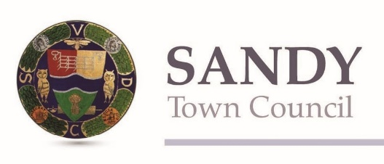
Presented by Let’s Get Going, Sandy Centre Group and Sandy Town Council
Sandy Easter Bunny Trail 2021
6-11 year olds
Name:

Age:

Parent email address:
Parent contact number:

Aim of the game: Follow the clues and walk or run around the trail, answering the quiz questions on this form. When you have completed the quiz, email it to admin@sandytowncouncil.gov.uk

Deadline is 7th April!
There are prizes for 1st, 2nd and 3rd place, judged on the most correct answers and loveliest picture.
Good luck!
Starting place: The High Street Community Stand (outside the Post Office) – ready……..set……..let’ go!!

1. How many bunnies are in the Post Office window? What would you like to say to the Post Office staff for their help over the last year?

2. What colour are the bunnies in Pecoro's window, and how many bunnies are there? What is your favourite thing about Pecoro?

3. Go to Gunns Bakery. How many bunnies are in this window? What is your favourite treat from Gunns?

4. If a big stride is about 1 metre, how many big strides, or metres, is it from the door of Gunns Bakery to the door of McColls? What is the colour of the bunny in McColls? Where is it?

5. Now to the chemist; keep going until the second Britannia Pharmacy – what colour are the bunnies in this window, and how many are there?

6. Be careful and cross the road to the bus shelter. What number bus would we get if we were going to Bedford?

7. At Rasoi, one of our fine Indian restaurants, how many bunnies can you find in the window? Can you name a favourite dish from Rasoi?

8. Turn around and look across the road to see the BETFRED Building. Can you find the numbers which show how old the building is?

9. Now go to the pelican crossing and use the traffic lights to safely cross the High Street. Turn left and walk up Park Road. How many bunnies are in Inskip and Davie's window?

10. Look at the next building - Urban Kutz. How old is this building? Can you see the numbers?

11. Carefully cross over Park Road and keep going to All Seasons. What colour is the dress on the rabbit in All Seasons’ window and how many rabbits have come to the shop here?

12. Keep walking along the High Street to St Swithuns Church. What type of trees are in the church yard? What do you love about trees?

13. What is the little building within the church ground called?

14. Can you see the 2 black iron shapes on the outside of this building? What do they look like? What do you think they are there for?

15. Keep walking in the same direction and look around. What is sold inside Gilby’s? How many bunnies are in the window?

16. Walking past St Swithuns School, can you find more mosaics? What animals are shown in the long, curved mosaic?

17. Look around you. What is the name of the court shown here?
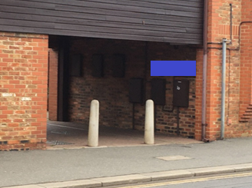

18. Carefully cross the road and go through this little walkway. Keep walking straight ahead until you come to another road with cherry trees along it – this is St Swithuns Way. Turn right and go along St Swithuns Way until you reach a crossroad.

Now we’re looking for a road called Stonecroft. St Swithuns Way is the road behind you, and carries on around the corner to the right. You’ll see the road on the left is called Cherrycroft. This means Stonecroft is the road straight in front of you. Cross the road carefully and walk up Stonecroft.

Look out for a path on the left which runs behind some people’s back gardens. Follow this path until you see a bridge - don’t cross over the bridge though! Turn to the left and walk along the little pathway that runs between more gardens and the railway (so the railway is on your right).

You will come out at the end of Cambridge Road. Look around to find this sign; when you can see this, what is on the left hand side ? What is it made from?
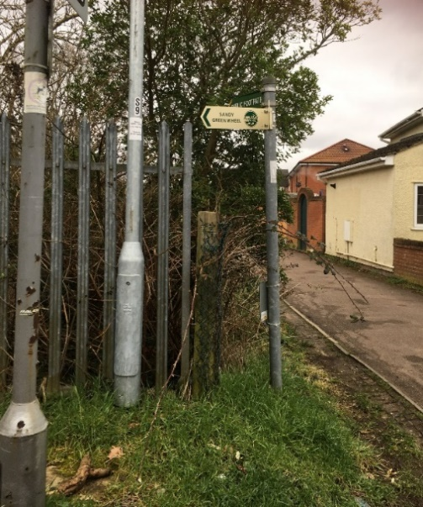

19. Turn around and continue along Brickhill Road with the railway on your right-hand side. Near the end of the road, turn right, up a small hill, and cross over the railway bridge.

Walk a little way alongside the track (the railway should now be on your left!) If you could take anybody in the world on a special train journey, somewhere they really wanted to go, where would it be and why?

20. When you get to this gate which crosses the path, how many horizontal bars are there?
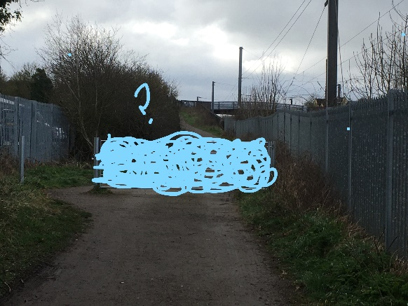
21. Walk around the side of the gate and keep going.
The next metal object on your right looks like this. There are some flowers just in front, what type of flowers are they?
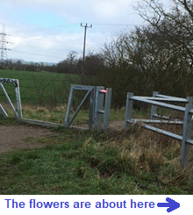

22. Turn right and walk down this path. Walk along this bridleway past some fields and farm buildings, and follow it around to the right where it becomes a solid surface.

At the crossroads turn right – back onto a dirt track - and follow the signs for the ‘Green Sand Ridge Walk’ all the way to Sand Lane. There is a gate to go through – make sure to close this behind you - then you’ll go through a beautiful green field with a 2 oak trees in the middle.

The path goes uphill, diagonally across the field; head for the metal gate which leads to Sand Lane. This field sometimes has animals in it; do you know which ones? They might be in a nearby field.

23. When you get to Sand Lane, turn right and follow the road towards Sandy – you’ll go uphill, through a wood and downhill again. If you see any horses, what names would you give them?

24. At the end of Sand Lane, cross the railway bridge, then continue straight all the way down Cambridge Road.

Using the pelican crossing again, head towards the Co-Op and then turn right. Be careful to stop and look when using the zebra crossing at the entrance to the Co-Op car park.

One of the shops on the raised section in front of you has some bunnies in their window; which shop is it and how many bunnies are there?
25. I have heard rabbits like to borrow books. Can you see if that is true? If yes, how many bunnies are borrowing books right now?

26. This mosaic is in Sandy. There are three sections in this mosaic linked by the blue wavy line.
What do you think the blue line represents? Which part of the mosaic shows the water mill?
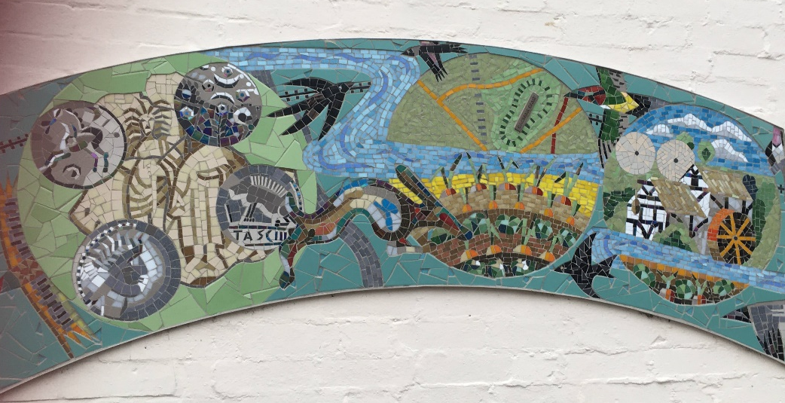

27. Cross over at the zebra crossing so you are on the same side of the road as the Post Office. Why is the crossing named after a zebra? Can you guess why zebras have this special pattern?

28. There is one more business which may have some bunnies visiting, between the zebra crossing and the Post Office. What is the business called and how many bunnies are in there?

29. On the next page there is a box for you to fill by drawing a picture or writing a few words about what you like most about Easter and Springtime.
What I like about Easter and Springtime:

Well done!
Now enter your quiz - the deadline is the 7th April.
Submit to admin@sandytowncouncil.gov.uk for your chance to win a prize!
Thanks for taking part, good luck, we hope you had fun and we hope you win!

Created by Let’s Get Going CIC

